Master Technical Specification & Architecture Blueprint: Unified POS System
Target Platform: Windows POS Terminals (.NET 8 Native + Embedded SQLite)
Backend: ERPNext v14/v15 REST Engine
Deployment Phases:
- Phase 1A: Al Ain Market Cash Counters (Offline-first Supermarket MVP)
- Phase 1B: QuickGroc Dark Store & E-Commerce Picker Fulfillment
- Phase 2: Kattcho Multi-Brand Virtual Cloud Kitchen (KOT & Aggregators)
Stakeholders: Jawad Jahangir (Product Owner), Babar (Lead Developer), Shibin (Technical Architect & QA)

1. System Architecture & Performance Benchmarks
The native desktop architecture eliminates web browser runtime overhead on low-spec Intel Celeron J1900/J6412 terminals (4GB RAM). It replaces the Chromium-based stack with a compiled C# .NET 8 native application (WPF/WinUI 3) backed by an in-process SQLite database operating in Write-Ahead Logging (WAL) mode.

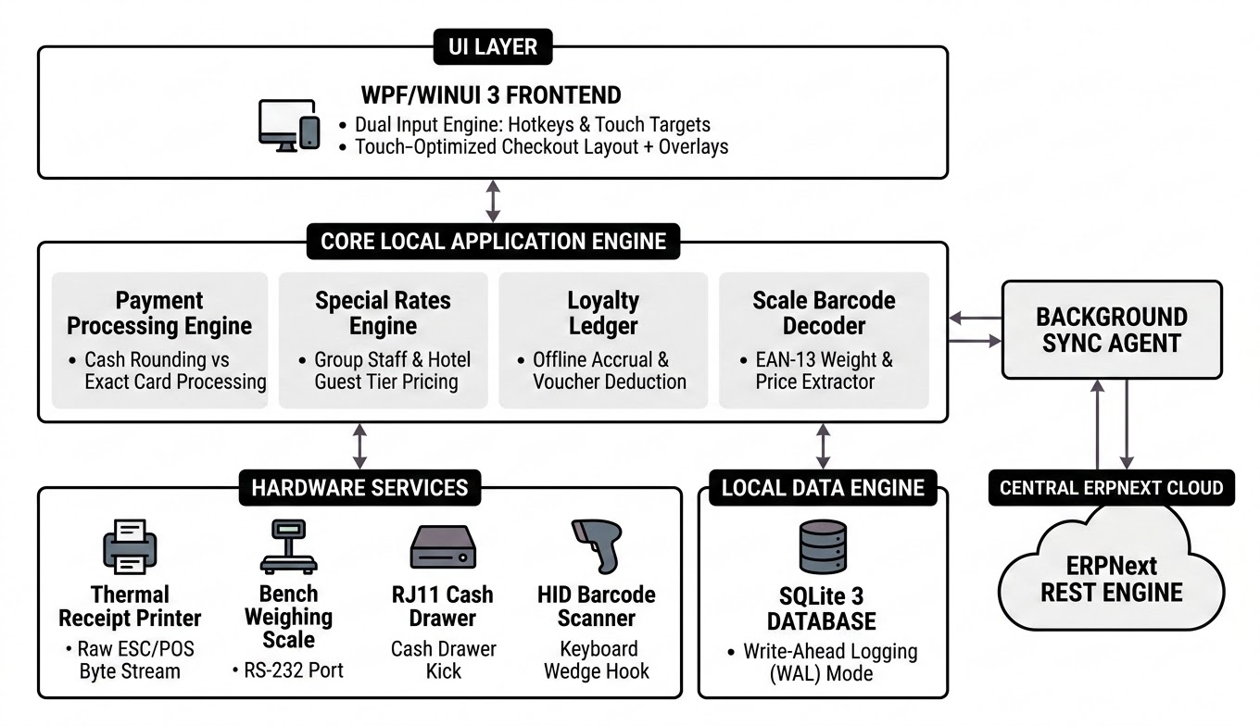

Execution Benchmarks
- Memory Budget: Strictly $\le 90$ MB RAM working set under 10-hour continuous shifts.
- Scan-to-Cart Pipeline: $\le 15$ ms total execution time from barcode scanner input to UI render.
- Database Query Latency: $\le 1$ ms local lookup on an indexed 20,000-SKU SQLite table.
- Receipt Execution: $\le 200$ ms from tender commit to physical thermal paper feed.
- Offline Autonomy: 100% functionality maintained during complete internet outages.

2. Hardware Peripheral Integration Directives
All peripheral communication routes through low-level C# libraries, bypassing Windows print spoolers and browser sandboxes.
Hardware Device | Communication Layer | Implementation Directive
80mm Thermal Receipt Printer | Raw ESC/POS Byte Stream | Direct byte pipe over USB/Network (RawPrinterHelper). Streams text, cuts paper, and outputs UAE FTA TLV QR codes without print dialogs.
RJ11 Cash Drawer | Printer Pin 2 Pulse | Commands ESC p 0 25 250. Strict Condition: Trigger ONLY on Cash transactions. Completely suppress kick-out for Card, Loyalty, or Hotel Room charges.
Bench Weighing Scale | RS-232 / Virtual COM Port | Direct System.IO.Ports.SerialPort streaming (9600 baud, 8-N-1). Reads ASCII protocols (CAS, Dibal, Mettler Toledo). Extracts stable net weight; blocks un-stabilized reads.
Barcode Scanner | USB HID Keyboard Wedge | Low-level keyboard hook intercepting rapid keystrokes ($<50$ ms threshold) to capture scans without requiring text box focus.
Customer Pole Display (VFD) | Serial COM / USB Pass-Through | Standard 20x2 character VFD. Line 1: Scanned item & price. Line 2: Running subtotal or change due in AED.
Shift-in-Charge Access | USB HID Reader / Scanner | Intercepts RFID badge scans, magnetic cards, or supervisor 2D employee barcodes for zero-touch managerial authorizations.

3. Financial, UAE Tax, and Payment Engine

UAE FTA VAT Compliance (5% Statutory Tax)
- All catalog shelf prices are stored as VAT-inclusive.
- The core checkout calculation engine applies:
$$\text{Net Price} = \frac{\text{Gross Price}}{1.05}$$
$$\text{VAT Amount} = \text{Gross Price} - \text{Net Price}$$
- Thermal receipts must include a UAE FTA-compliant TLV Base64 QR Code containing:
  - Seller Name (AL AIN MARKETING L.L.C)
  - VAT Registration Number (TRN)
  - Invoice Timestamp (YYYY-MM-DDTHH:mm:ssZ)
  - Invoice Total (VAT-inclusive)
  - Total VAT Amount

Dual Rounding Logic (Cash vs. Card)
Different tenders handle fractional decimals under specific rounding rules:
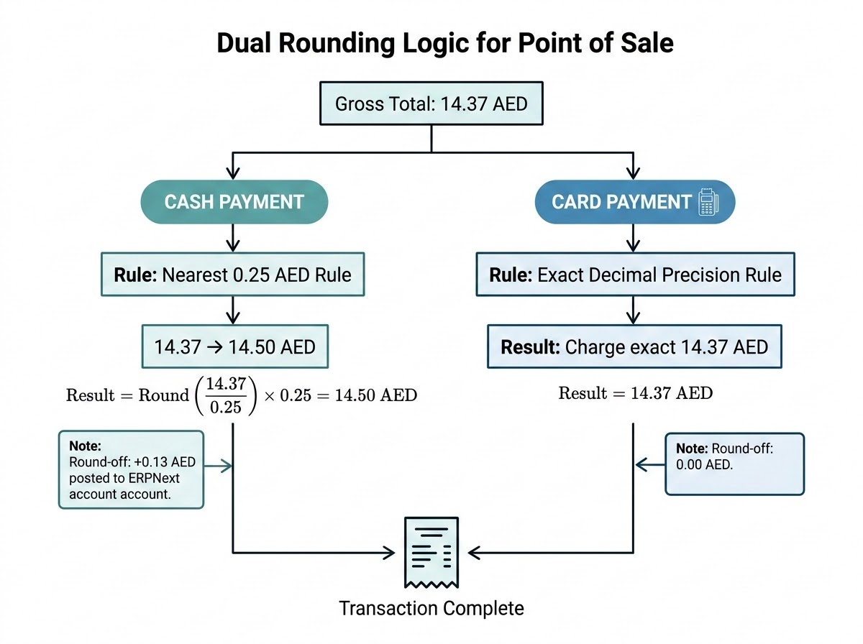

- Cash Payments:
  - Apply mathematical rounding to the nearest 0.25 AED (or configurable 0.05 AED):
$$\text{Payable Cash} = \text{Round}\left(\frac{\text{Gross Amount}}{0.25}\right) \times 0.25$$
  - Post rounding variance to the ERPNext Round Off account.
- Debit & Credit Cards:
  - Strict Rule: Zero rounding applied. The exact unrounded decimal total (e.g., 14.37 AED) is processed.
- Split Payments:
  - Card portion processes at exact value.
  - The remaining balance applies Cash rounding:
$$\text{Remaining Gross} = \text{Gross Total} - \text{Card Amount}$$
$$\text{Cash Due} = \text{Round}\left(\frac{\text{Remaining Gross}}{0.25}\right) \times 0.25$$

4. Special Commercial Programs

A. Customer Loyalty Points Program
- Earning Mechanics: Customers earn points per dirham spent (e.g., 1 Point per 10 AED). Points calculate against net payable totals, excluding tax-exempt fees.
- Redemption Rules:
  - Points redeem at a fixed conversion rate (e.g., 100 Points = 5.00 AED credit).
  - System requires customer mobile number lookup and enforces minimum redemption thresholds.
  - Point redemptions register as a payment tender method (Loyalty Points), reducing the remaining balance.
- Offline Safeguards: Local SQLite caches customer balances. When offline, point redemptions are capped at a safety threshold (e.g., max 20.00 AED per offline receipt) to prevent point-replay fraud across different registers.

B. Group Staff Discount Program
- Eligibility: Staff across group sister companies (Bright Way Detergents, Al Ain Group, AIJ Trading) receive fixed corporate discounts (e.g., 10% to 15%).
- Verification: Cashier selects Staff Discount and scans the employee's corporate ID card or enters their Employee ID.
- Calculation: The discount applies to the Gross Price of eligible items before line subtotal generation. Items on active promotional offer ("Super Sale") are flagged as non-discountable in SQLite to prevent negative margin loss.
- Auditing: Invoices record custom_employee_id and custom_staff_company for internal HR auditing.

C. Group Hotel Guest Discount Program
- Eligibility: Guests staying at group-partner hotels qualify for retail promotions.
- Verification: Cashier selects Hotel Guest Discount, inputs the guest's Room Number, and selects the Hotel Entity (or scans a hotel voucher barcode).
- Execution: System applies configured hotel tier discounts (e.g., 10% discount on non-promotional goods). The invoice metadata tags the hotel reference ID, enabling back-to-back cross-entity marketing analysis in ERPNext.

5. Security, Auditing & Access Control (Shift-in-Charge Privileges)
To prevent cash register shrinkage and unverified stock deductions, administrative operational overrides are locked behind authentication gates:

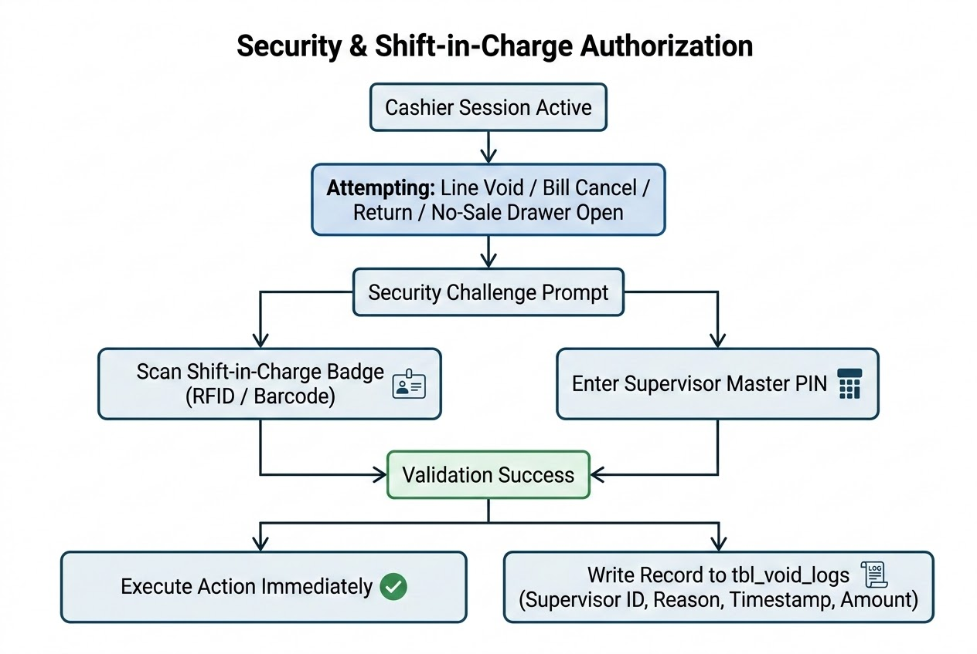
Restricted Actions
- Single Line Void: Removing an item already added to an active cart.
- Total Bill Cancellation: Voiding an entire order with multiple scanned products.
- Product Returns & Refunds: Processing item returns without an original invoice lookup, or returns exceeding 50 AED.
- Manual Line Discount: Overriding standard cashier discount thresholds ($>5\%$).
- No-Sale Drawer Open: Popping the cash drawer without an active sale.

Verification Flow
- The register displays an overlay challenge modal.
- The Shift-in-Charge either swipes their RFID/magnetic badge, scans their supervisor barcode, or enters a 4-to-6-digit PIN.
- Every approved event logs locally to tbl_void_logs and syncs to ERPNext as a child log on the cashier's shift closing entry.

6. Supermarket Features & Register Controls (Phase 1A)
- Produce Scale Barcode Parsing (EAN-13 Prefixes 20 & 22):
$$\underbrace{\text{20 / 22}}_{\text{Scale Identifier (2)}} \quad \underbrace{\text{XXXXX}}_{\text{PLU Code (5)}} \quad \underbrace{\text{YYYYY}}_{\text{Weight (g) or Price (cents) (5)}} \quad \underbrace{\text{C}}_{\text{Checksum (1)}}$$
The engine dynamically parses the PLU, retrieves the base item code, calculates weight ($\text{Weight} = YYYYY / 1000 \text{ kg}$), and computes totals on the fly without dedicated database SKUs for each weighed label.
- Cart Parking (Hold & Recall): Instant one-touch cart hold (F5) writes current lines to SQLite, freeing the terminal for the next customer. Rapid recall (F7) restores held baskets.
- Price Check Mode (F4): Scans an item to display its description, VAT-inclusive price, promotion status, and available stock on an overlay without modifying the active cart.
- Multi-Currency Cash Acceptance: Accepts GCC Currencies (SAR, OMR, BHD, KWD) and USD using synced exchange rates. System auto-converts to AED, applies cash rounding, and displays change due in AED.
- Blind Cash Count (Shift Z-Report): During shift reconciliation, the cashier enters physical cash counts by denomination without viewing the system's expected total. This prevents cash skimming and provides clean variance reporting (Over/Short) to ERPNext.

7. Multi-Phase System Expansion

Phase 1B: QuickGroc E-Commerce Dark Store Picker Mode
- Mode Toggle (F10: Picker Mode): Replaces the register screen with a warehouse fulfillment interface.
- ERPNext Order Stream: Ingests unfulfilled online delivery orders.
- Aisle Routing: Orders sort automatically by warehouse bin location (Aisle $\rightarrow$ Rack $\rightarrow$ Shelf).
- Scan-to-Pack Validation: Pickers must scan item barcodes; mismatch scans trigger audio and visual alerts.
- Produce Tolerance Check: Weighs produce against ordered quantities, allowing an automated variance tolerance of $\pm 10\%$.

Phase 2: Kattcho Virtual Kitchen System
- Kitchen Order Ticket (KOT) Routing: Dispatches food orders to network ESC/POS thermal printers (TCP port 9100) filtered by station (Grill, Fryer, Assembly, Beverage).
- Variant & Modifier Trees: Supports multi-tiered parent-child modifiers (e.g., Burger $\rightarrow$ Patty Doneness $\rightarrow$ Add Cheese).
- Aggregator Ingestion: An API listener ingests webhooks from food delivery platforms (Talabat, Deliveroo, Noon, Careem), printing tickets directly in the kitchen.

8. Embedded SQLite Schema & Sync Protocol

SQL
PRAGMA journal_mode = WAL;
PRAGMA synchronous = NORMAL;
PRAGMA cache_size = 10000;
PRAGMA temp_store = MEMORY;
-- Core Catalog Table
CREATE TABLE tbl_items (
item_code TEXT PRIMARY KEY,
item_name TEXT NOT NULL,
uom TEXT NOT NULL,
is_stock_item INTEGER DEFAULT 1,
is_scale_item INTEGER DEFAULT 0,
non_discountable INTEGER DEFAULT 0
);
-- Barcode Mapping Table
CREATE TABLE tbl_barcodes (
barcode TEXT PRIMARY KEY,
item_code TEXT NOT NULL,
uom TEXT,
FOREIGN KEY(item_code) REFERENCES tbl_items(item_code)
);
CREATE INDEX idx_barcodes_lookup ON tbl_barcodes(barcode);
-- Retail Price Table (Standard Selling)
CREATE TABLE tbl_prices (
item_code TEXT PRIMARY KEY,
price_list_rate REAL NOT NULL, -- Stored VAT-Inclusive
FOREIGN KEY(item_code) REFERENCES tbl_items(item_code)
);
-- Customers and Loyalty Points
CREATE TABLE tbl_customers (
phone TEXT PRIMARY KEY,
customer_name TEXT NOT NULL,
loyalty_points INTEGER DEFAULT 0,
is_staff INTEGER DEFAULT 0,
staff_id TEXT,
hotel_guest_id TEXT
);
-- Shift Supervisors & Access Auth
CREATE TABLE tbl_supervisors (
supervisor_id TEXT PRIMARY KEY,
name TEXT NOT NULL,
pin_hash TEXT NOT NULL,
badge_uid TEXT UNIQUE
);
-- Audit Logging for Restricted Actions
CREATE TABLE tbl_void_logs (
log_id TEXT PRIMARY KEY,
invoice_id TEXT,
action_type TEXT, -- LINE_VOID, BILL_VOID, RETURN, NO_SALE
item_code TEXT,
amount REAL,
supervisor_id TEXT,
reason TEXT,
timestamp DATETIME DEFAULT CURRENT_TIMESTAMP
);
-- FIFO Invoice Outbox Sync Queue
CREATE TABLE tbl_sales_queue (
local_id TEXT PRIMARY KEY,
payload JSON NOT NULL,
status TEXT DEFAULT 'PENDING', -- PENDING, SYNCED, FAILED
retry_count INTEGER DEFAULT 0,
created_at DATETIME DEFAULT CURRENT_TIMESTAMP,
synced_at DATETIME
);

Sync Protocol (ERPNext REST Engine)
- Delta Pull (Every 60 Seconds):
  - Endpoint: GET /api/resource/Item?filters=[["modified",">=","{last_sync_timestamp}"]]
  - Updates only modified items, barcodes, prices, and customer balances within a single local transaction.
- Idempotent Push (FIFO Invoices):
  - Assigns every invoice a UUIDv4 client reference: TILL{No}-{Timestamp}-{Sequence}.
  - Background service sends payload to POST /api/resource/POS Invoice, writing the UUID to custom_pos_client_id.
  - If network connection drops mid-flight and retries, ERPNext identifies the existing custom_pos_client_id and returns the existing record without duplicating accounting or inventory deductions.

Developer Prompt: Implementation Instructions
Plaintext
You are an expert enterprise systems architect and principal C# / .NET engineer. You are tasked with developing a lightweight, high-performance, offline-first Point of Sale (POS) system for Windows called "QuickGroc POS" (.NET 8 WPF or WinUI 3).
This POS replaces a legacy web interface on low-spec touchscreen terminals (Intel Celeron J1900/J6412 with 4GB RAM) operating at Al Ain Market. The application must consume strictly less than 90 MB of RAM, provide instant barcode scanning (<15 ms), interface directly with hardware peripherals, and bidirectionally sync with an ERPNext v14/v15 backend.
Phase 1 focuses on building the Supermarket Cash Register MVP first, followed by the QuickGroc Picking Mode. Phase 2 extends the platform for Kattcho Cloud Kitchen operations.
Implement the project following the clean architecture guidelines, technical specifications, and coding standards below:
--------------------------------------------------------------------------------
1. ARCHITECTURAL PATTERN & PROJECT STRUCTURE
--------------------------------------------------------------------------------
Create a .NET 8 solution using Clean Architecture and the MVVM pattern (CommunityToolkit.Mvvm):
- QuickGroc.Core: Domain models, interfaces, financial rounding logic, and business rules.
- QuickGroc.Data: SQLite database connection (sqlite-net-pcl / Microsoft.Data.Sqlite), WAL mode, repository implementations, and migration scripts.
- QuickGroc.Hardware: Direct ESC/POS printing (RawPrinterHelper), RS-232 serial scale communication, cash drawer control, RFID/badge authentication hooks, and keyboard wedge listeners.
- QuickGroc.Sync: Non-blocking background worker services for delta pulling and idempotent FIFO pushing to ERPNext via REST APIs.
- QuickGroc.UI: Touch-optimized XAML frontend (1024x768 / 1920x1080 responsive layouts) with strict keyboard hotkey bindings.
--------------------------------------------------------------------------------
2. LOCAL SQLITE DATABASE SPECIFICATIONS
--------------------------------------------------------------------------------
Configure SQLite to execute the following initialization flags immediately upon opening:
PRAGMA journal_mode = WAL;
PRAGMA synchronous = NORMAL;
PRAGMA cache_size = 10000;
PRAGMA temp_store = MEMORY;
Create tables with explicit indexes:
- Items: ItemCode (PK), ItemName, UOM, IsStockItem, IsScaleItem, NonDiscountable.
- Barcodes: Barcode (PK), ItemCode (FK), UOM. (Index on Barcode).
- ItemPrices: ItemCode (PK), PriceListRate (VAT-inclusive).
- Customers: Phone (PK), CustomerName, LoyaltyPoints, IsStaff, StaffId, HotelGuestId.
- Supervisors: SupervisorId (PK), Name, PinHash, BadgeUid.
- VoidLogs: LogId (PK), InvoiceId, ActionType, ItemCode, Amount, SupervisorId, Reason, Timestamp.
- SalesQueue: LocalId (PK), Payload (JSON), Status (PENDING/SYNCED/FAILED), RetryCount, CreatedAt, SyncedAt.
- ShiftRegisters: ShiftId (PK), CashierId, OpeningFloat, ClosingCash, Variance, Status, OpenedAt, ClosedAt.
--------------------------------------------------------------------------------
3. FINANCIAL ENGINE & PAYMENT ROUNDING (CRITICAL SPECIFICATION)
--------------------------------------------------------------------------------
Implement a dedicated service PaymentCalculationService.cs:
1. UAE VAT Calculation (5% VAT):
- All catalog prices are VAT-inclusive.
- Net Rate = Gross Rate / 1.05
- Line VAT = Gross Rate - Net Rate
2. Payment Rounding Rules:
- CASH PAYMENTS: Must round to the nearest 0.25 AED:
Formula: RoundedTotal = Math.Round(GrossTotal / 0.25m, MidpointRounding.AwayFromZero) * 0.25m
Calculate Variance: RoundOffAmount = RoundedTotal - GrossTotal.
- CARD PAYMENTS (Debit / Credit): STRICTLY NO ROUNDING ALLOWED.
The exact unrounded gross total (e.g., 14.37 AED) must be recorded and passed to card processing. RoundOffAmount = 0.00m.
- SPLIT PAYMENTS:
If paying partially with Card and balance with Cash:
Apply exact card payment first: RemainingGross = GrossTotal - CardAmount.
Cash portion rounds: RoundedCash = Math.Round(RemainingGross / 0.25m, MidpointRounding.AwayFromZero) * 0.25m.
RoundOffAmount = RoundedCash - RemainingGross.
--------------------------------------------------------------------------------
4. COMMERCIAL & DISCOUNT MODULES
--------------------------------------------------------------------------------
1. Customer Loyalty Engine:
- Calculate accrual points: 1 Point per 10 AED spent.
- Redemption: Deduct points as currency value (100 Points = 5.00 AED).
- Offline threshold protection: Enforce max 20.00 AED point redemption if connection status is Offline.
2. Group Staff Discount Engine:
- Staff verified by Employee Card Scan or Staff ID entry.
- Applies configured discount percentage (e.g., 10%) on eligible lines.
- Exclude lines where NonDiscountable == 1.
3. Group Hotel Guest Discount Engine:
- Verified via Hotel selection and Room Number input.
- Applies hotel tier discount to invoice and stores hotel reference metadata for reporting.
--------------------------------------------------------------------------------
5. SECURITY & SHIFT-IN-CHARGE AUTHORIZATION GATE
--------------------------------------------------------------------------------
Implement SecurityAuthorizationService.cs:
- Restrict sensitive actions: Line Void, Bill Cancellation, Returns/Refunds, Manual Overrides, and Drawer Kick (No Sale).
- Intercept authorization challenge via either:
a) RFID / Barcode Badge Scan (matched against Supervisors.BadgeUid).
b) 4-to-6 digit PIN entry (verified against Supervisors.PinHash).
- Every successful override must write an immutable entry to tbl_void_logs and attach supervisor metadata to the sale payload.
--------------------------------------------------------------------------------
6. HARDWARE SERVICES IMPLEMENTATION
--------------------------------------------------------------------------------
1. RawPrinterService.cs:
- Send raw byte streams directly to thermal printers over USB/Network without using the Windows GDI print spooler.
- Print UAE FTA-compliant TLV Base64 QR codes on 80mm receipts.
- Cash Drawer Kick: Send byte command `ESC p 0 25 250` to pin 2.
- STRICT ENFORCEMENT: The cash drawer kick command must ONLY fire if TenderType == PaymentMode.Cash. Suppress kick command for Card transactions.
2. ScaleService.cs:
- Manage COM serial port connection using System.IO.Ports.SerialPort.
- Read continuous ASCII data streams (CAS / Dibal protocol), parse stable weight, filter noise, and return weight in kg.
3. ScaleBarcodeParser.cs:
- Parse supermarket embedded scale barcodes (13 digits starting with '20' or '22').
- Format: [Prefix: 2 digits][PLU: 5 digits][Weight/Price: 5 digits][Checksum: 1 digit].
- Extract PLU, resolve ItemCode from database, and calculate weight in kg (Weight = Value / 1000m).
--------------------------------------------------------------------------------
7. BIDIRECTIONAL SYNC ENGINE (ERPNEXT REST API)
--------------------------------------------------------------------------------
Implement SyncBackgroundService.cs as a hosted background service:
1. PULL ENGINE (Incremental Delta Pull every 60s):
- Track last_sync_timestamp.
- Query ERPNext endpoints:
GET /api/resource/Item?filters=[["modified",">=","{last_sync_timestamp}"]]
GET /api/resource/Item Price?filters=[["modified",">=","{last_sync_timestamp}"],["price_list","=","Standard Selling"]]
- Update SQLite database atomically within a single local transaction.
2. PUSH ENGINE (FIFO Queue with Idempotency):
- Invoices save to local SQLite table SalesQueue with status PENDING before network sync is attempted.
- Assign each receipt a UUIDv4 client ID: TILL{TillNumber}-{Timestamp}-{Sequence}.
- POST to /api/resource/POS Invoice mapping custom_pos_client_id to this UUID.
- If network drops and retries, ERPNext checks custom_pos_client_id. If record already exists, treat as successful and update local status to SYNCED to prevent duplicate ledger and stock entries.
--------------------------------------------------------------------------------
8. CASHIER UI & OPERATIONAL WORKFLOW (PHASE 1 CASH COUNTER PRIORITY)
--------------------------------------------------------------------------------
Design touch-friendly XAML screens (WPF/WinUI) supporting full physical keyboard controls:
- Hotkeys:
[F1] Help / Shortcuts
[F2] Search Item Catalog
[F3] Set Quantity
[F4] Price Check Mode (Full-screen overlay showing price and stock without adding to cart)
[F5] Hold Bill (Park active cart to SQLite)
[F6] Return Mode
[F7] Recall Bill (Resume parked cart)
[F8] Line Discount
[F9] Total Bill Discount
[F10] QuickGroc Picker Mode Toggle
[F11] Card Payment
[F12] Cash Payment
[Enter] Add Item / Confirm
[Esc] Cancel / Back
- Touchpad buttons:
- Denomination quick buttons: 10, 20, 50, 100, 200, 500 AED.
- Line Void and Bill Void requiring Supervisor verification modal.
- Blind Cash Count window for Z-Report Shift Close.
--------------------------------------------------------------------------------
9. FORWARD COMPATIBILITY ARCHITECTURE (PHASE 2: KATTCHO CLOUD KITCHEN)
--------------------------------------------------------------------------------
Ensure domain interfaces and data schemas support:
- Station-based KOT network routing: Items tagged with stations (Grill, Fryer, Assembly, Beverage) route print commands over raw TCP port 9100 to target kitchen station printers.
- Recursive item variant/modifier support (Item -> Modifier Group -> Modifier Items with price deltas).
- External order webhook model designed to ingest third-party delivery orders (Talabat, Deliveroo, Noon, Careem).
--------------------------------------------------------------------------------
DELIVERABLES REQUIRED:
--------------------------------------------------------------------------------
Generate production-ready C# code starting with:
1. Complete Solution Directory Structure & Dependencies.
2. PaymentCalculationService.cs (UAE VAT, Cash 0.25 rounding vs exact Card precision, Staff & Hotel discounts, Loyalty calculations).
3. SecurityAuthorizationService.cs (Supervisor PIN & RFID Badge scan validation, Void audit logging).
4. ScaleBarcodeParser.cs (handling 20/22 prefixes, PLU extraction, and weight/price calculations).
5. RawPrinterService.cs (ESC/POS byte sender, drawer kick suppression on Card, and receipt formatting).
6. SyncBackgroundService.cs (Delta sync pull and idempotent FIFO push logic).

